Use-Case Realization Report (Requirements)
Dispense Drink

Issue 3.0
Revision History
Date | Issue | Description | Author
13 July 2000 | 1.0 | First Issue | Howard Russon
20 July 2001 | 2.0 | Revised for MTech Unit 3 in 2001 | Howard Russon
22 July 2004 | 3.0 | Revised for MTech Unit 3 in 2004 | Howard Russon

Table of Contents
1. Brief Description 4
2. Flow of Events 4
2.1 Standard Flow 4
2.2 Exceptions 4
3. Interaction Diagrams 5
3.1 Domain Collaboration Diagram: Dispense Drink 5
4. Participating Objects 5
5. Class Diagrams 6
5.1 Domain Class Diagram: Dispense Drink 6
6. Derived Requirements 6

Use-Case Realization Report
Dispense Drink

Brief Description
This abstract use case enables the selected brand to be dispensed to the Customer.

Flow of Events
The standard flow of events for this use case and any exceptions are described in the following subsections. See section 3.1 for an overview of the participating Actors and Domain Objects.

Standard Flow
This use case is used by use case Coin Input and Select Brand to dispense a selected drinks can to the Customer as follows:
- Having selected a Drinks Brand and entered sufficient money, the selected brand will then be dispensed to the Customer.
- To achieve this in the computer simulation, the number of cans of the selected brand will be decremented by one can, and an appropriate text message will be displayed next to the caption “Collect Can Here” on the Customer Panel
- If dispensing this can has made a Drinks Brand become out of stock, then the caption “Not in Stock” shall be highlighted in line with the corresponding brand button on the Customer Panel. Also, the button corresponding to unavailable brand will be deactivated (ie: it will not respond if pressed).
- Finally, the Machinery Simulator Panel will be updated to show the new stock level for the dispensed Drinks Brand.

Exceptions
The following exceptions have been identified:
- Fault is Detected. If the sensors detect a fault while dispensing a drinks can (resulting in no can being dispensed) then a fault message is returned.
- Brand Not in Stock. If (for some unexplained reason) the Drinks Store is instructed to dispense a Drinks Brand which is out of stock, then the request will be ignored and message will be returned saying that the Drinks Brand is not in stock.

Interaction Diagrams

Domain Collaboration Diagram: Dispense Drink
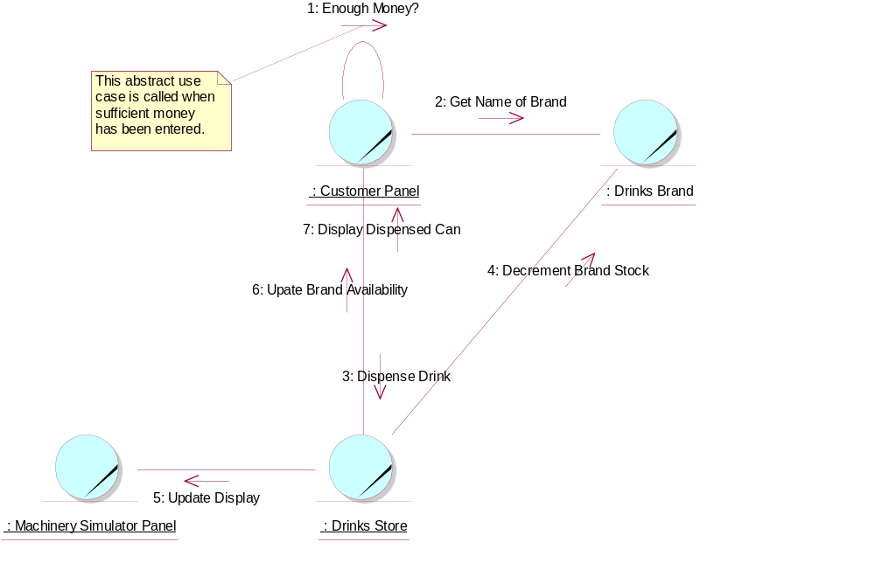

Participating Objects
: Customer Panel
This panel simulates the vending machine's customer interface panel. It will enable the user (the Customer) to:
1 insert coins;
2 select brands;
3 terminate transaction.
It will also provide the following display functions:
1 display total money inserted;
2 indicate coin not valid;
3 indicate no change available;
4 display the value of the change to be collected;
5 display an icon representing the dispensed drink.
: Drinks Brand
This object stores the characteristics of the types of drinks can held in the system.
: Drinks Store
This is the repository for the drinks cans held by the system.
: Machinery Simulator Panel
This panel simulates the physical actions of the maintainer. It enables the user to:
1 display and enter new values for the number of cans of each Drinks Brand held by the Drinks Store;
2 display and enter new values for the number of Coins of each denomination held by the Cash Store;
3 display whether the vending machine Door is unlocked, and enable it to be locked.

Class Diagrams

Domain Class Diagram: Dispense Drink
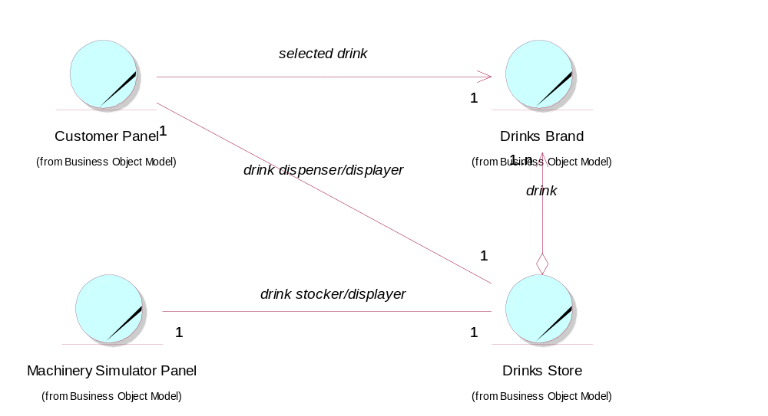

Derived Requirements
In the real vending machine, a drinks receiving tray is required to be built into the Customer Panel.

